AI ASSISTED CODING
LAB-16: Database Design and Queries: Schema Design and SQL Generation

Roll no: 2503A51L02
Name: G. Varshith Raju

Task-1 Description: Schema Generation
Task: Ask AI to design a schema for a Library Management System (Tables: Books, Members, Loans).
Prompt: Design a schema for a Library Management System (Tables: Books, Members, Loans).
Code Generated:
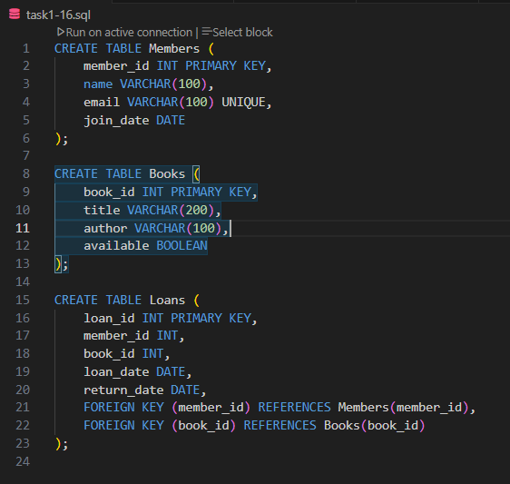

Observation: The AI successfully designed the Library Management System schema with the required tables and appropriate attributes to manage books, members, and loan details. It ensured proper structure that supports future query execution and relationships between tables. This task shows that AI can quickly and accurately create a complete database schema.

Task-2 Description: Error Insert Data
Task: Ask AI to generate INSERT INTO queries for the schema above (3 sample records per table).
Prompt: Generate INSERT INTO queries for the schema above (3 sample records per table).
Code Generated:
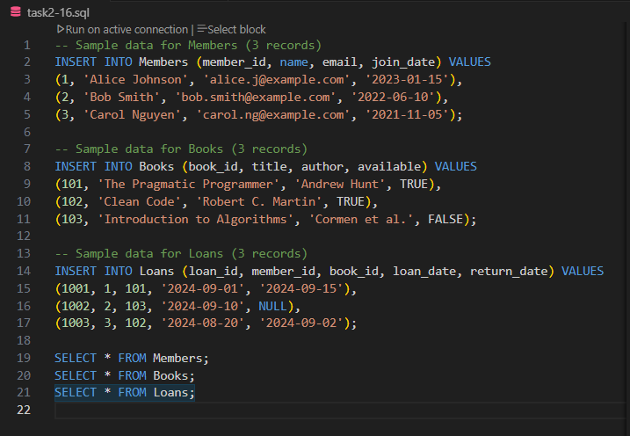

Output:
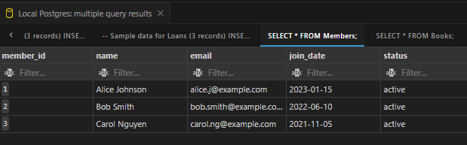

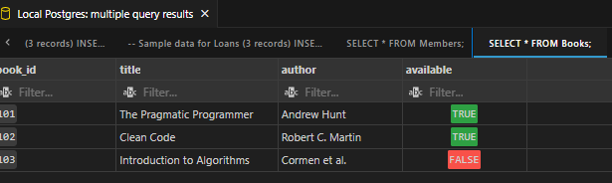

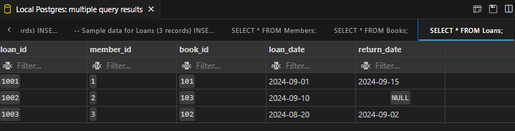

Observation: AI generated correct INSERT INTO statements with sample data for each of the tables created in Task-1. The execution of queries indicates proper syntax and ensures that the database has relevant test records. This task highlights AI’s usefulness in saving time while populating databases with meaningful sample data.

Task-3 Description: Basic Queries
Task: Use AI to generate a query to list all books borrowed by a specific member.
Prompt: Generate a query to list all books borrowed by a specific member.
Code Generated:
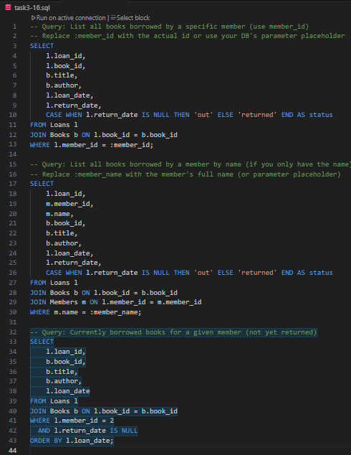

Output:
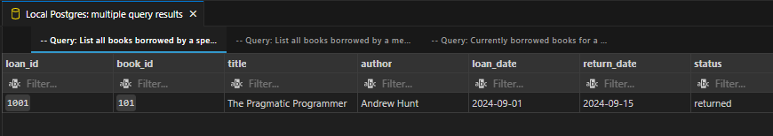
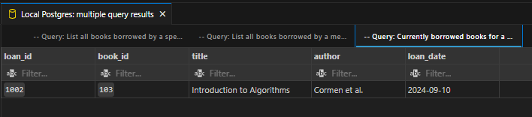
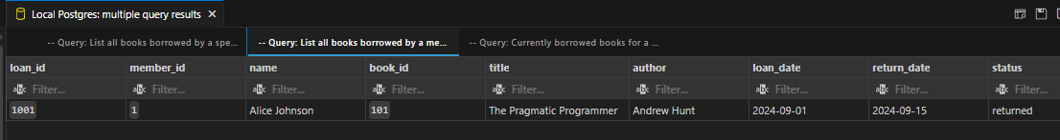
Observation: The AI provided an accurate SQL SELECT query to list books borrowed by a specific member, using table relationships effectively. It ensures correct retrieval of data from multiple tables, showing the practical application of the designed schema. This demonstrates how AI helps in generating precise queries for real-time information access.

Task-4 Description: Update and Delete Queries
Task: Generate queries with AI for:
- Updating a book’s availability to FALSE when borrowed.
- Deleting a member record safely.
Prompt: Generate queries for:
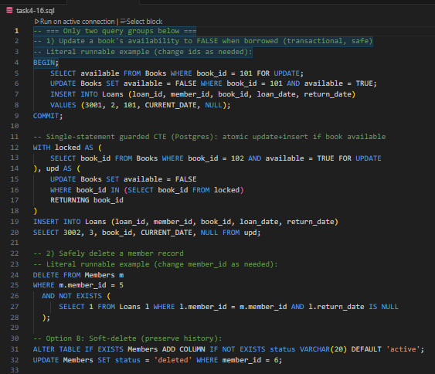
- Updating a book’s availability to FALSE when borrowed.
- Deleting a member record safely.
Code Generated:

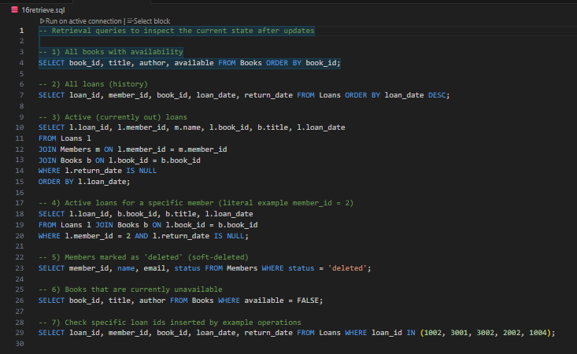

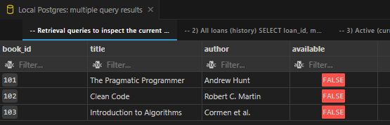
Output:

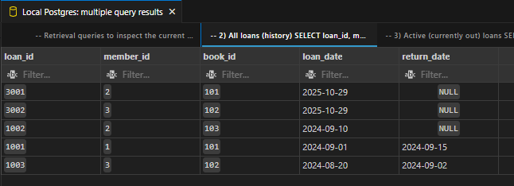

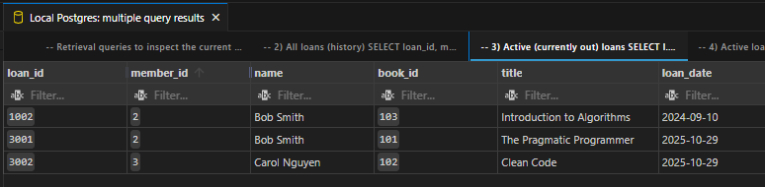

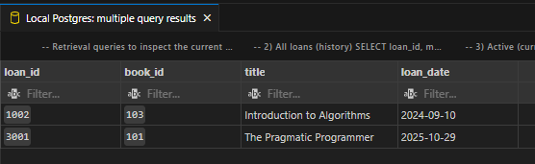

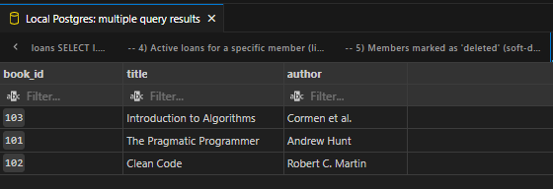

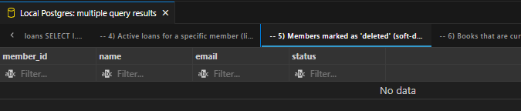
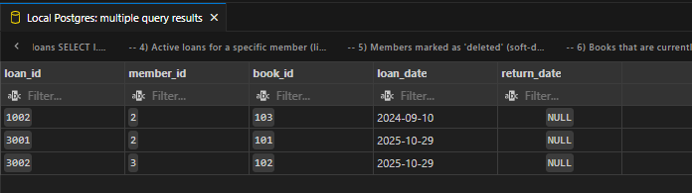

Observation: AI generated appropriate UPDATE and DELETE queries to manage changes in the database, including updating book availability and removing member details safely. The commands reflect secure handling of data modifications without affecting integrity. This task proves that AI can assist in maintaining and controlling database operations efficiently.

